Executive Summary

AP-05 Executive Summary - 24 CFR 91.200(c), 91.220(b)
1. Introduction
CITY OF TEXARKANA, ARKANSAS
2025 CDBG ANNUAL ACTION PLAN
Community Development Block Grant (CDBG)
The Community Development Block Grant (CDBG) Program is authorized Under Title I of the Housing and Community Development Act of 1974. The primary objective of the CDBG Program is the development of viable communities to benefit low and moderate-income persons. An activity (or project) must meet one of the following three National Objectives:
- Benefits to Low and Moderate-Income Persons
- Prevention or Elimination of Slums or Blighted areas as pre-approved by HUD
- Other Urgent Needs (as in a national disaster declared by the President or state declared disaster) (Please be advised that the City of Texarkana does not utilize the “Urgent Need” National Objective at this time.)
This One-Year Action Plan identifies specific activities which are to be conducted in support of many of the priorities and objectives outlined in the 2023-2027 Five-Year Consolidated Plan (CP) for the City of Texarkana, Arkansas. It is anticipated that the majority of the objectives of the CDBG program will be met and or exceeded. The One-Year Action Plan is updated and presents the specific programs and projects to be implemented in FY 2025 along with their respective funding sources and allocations.
During the fiscal year 2024, the Public Works Department of the City of Texarkana, Arkansas held public hearings to provide general information on the CDBG Program, national objectives, eligible activities, available funds and the process of applying for CDBG funds.
Notices of the public hearings and locations of the meetings were published in the Texarkana Gazette, the local newspaper on November 6th & 10th , 2024. This 2024 CDBG Budget was approved by the Board of Director’s on December 23, 2024, with Resolution No. 2024-103.
2. Summarize the objectives and outcomes identified in the Plan
This could be a restatement of items or a table listed elsewhere in the plan or a reference to another location. It may also contain any essential items from the housing and homeless needs assessment, the housing market analysis or the strategic plan.
This One-Year Action Plan identifies specific activities which are to be conducted in support of many of the priorities and objectives outlined in the 2023-2027 Five-Year Consolidated Plan (CP) for the City of Texarkana, Arkansas. It is anticipated that the majority of the objectives of the CDBG program will be met and or exceeded. The One-Year Action Plan is updated and presents the specific programs and projects to be implemented in FY 2025 along with their respective funding sources and allocations.
In the Five-Year Consolidated Plan, the City noted three types of obstacles to meeting underserved needs: (1) awareness of needs; (2) financial resources; and (3) capacity. In the FY 2025 funding year, the City will undertake a number of actions to address these obstacles.
The City will continue to encourage and seek input from the community on conditions and needs through public hearings, city council meetings, and other meetings with nonprofit organizations who serve low- to moderate-income persons through their programs. City staff will also continue to make numerous contacts within the community that are conduits for learning about the needs of our residents. City staff attend neighborhood meetings and are often asked to speak at these meetings.
During the coming year, the City will continue to provide CDBG funds to assist a range of needs in the community from senior services to providing funds for after school programs. Programs funded will be encouraged to extend their outreach to special needs and underserved groups.
3. Evaluation of past performance
This is an evaluation of past performance that helped lead the grantee to choose its goals or projects.
Quality public facilities, new public services, one residential home received major repairs and revitalized a neighborhood in a LMA are the successful projects in the City of Texarkana, Arkansas. Over the last five years the allowable amount of funds has been spent on public service, public facilities and housing demolition, thus creating a suitable living environment and revitalizing the LMA neighborhoods. CDBG has helped build and support projects that would have otherwise been impossible to achieve.
There is still a lack of committed citizen participation in the public hearing and community arena. Two community meetings were held for input on the 2025 Annual Action Plan. The City wants to present an opportunity to bring a different group of community residents to the table to hear their views of what is needed in the LMI neighborhoods.
Overall, major goals will be met, and significant progress is continually being made in regard to public service activities, housing, and public facilities. Demolition continues to be an area of great concern to everyone in the city. There are many abandoned structures that need to be torn down, but absentee landowners and available funds are the main barriers in this area. Therefore, the City is focusing on preserving the housing stock we currently have by partnering with Habitat for Humanity to offer a minor housing rehab program with emphasis on roof repair, attic insulation, minor wood replacement and outside house painting. This past year though we experienced issues that caused minor home repairs to become major home repairs as the home that were completed had underlying issues that were not seen at first.
4. Summary of Citizen Participation Process and consultation process
Summary from citizen participation section of plan.
Summary from citizen participation section of plan.
A press release was sent to the local media (newspaper, city webpage and city Facebook page). Listed herein, is the information submitted in the press release:
CITY OF TEXARKANA
FY 2025 COMMUNITY DEVELOPMENT BLOCK GRANT PROGRAM
ANNOUNCEMENT OF PUBLIC HEARINGS
The City of Texarkana, Arkansas ANTICIPATES that the U.S. Department of Housing and Urban Development will allocate Community Development Block Grant (CDBG) funds in an amount of $293,483.00. Agencies, organizations, public institutions and all citizens are invited to attend public hearings for the intent of providing input for budgeting of expenditures of funds administered by the Public Works Department 2024 Annual Action Plan. You may also bring recommendations to the Public Works Office Monday-Friday, 8 a.m. to 5 p.m. in Texarkana, Arkansas, City Hall Lower level.
Two (2) public hearings are scheduled at the following times and locations:
Monday, November 18, 2023, at 11:00 a.m. Arkansas City Hall, 216 Walnut Street, Texarkana, Arkansas
Monday, November 18, 2023, at 6:00 p.m. Texarkana Rec Center, 101 Legion Street, Texarkana, Arkansas
Technical questions regarding eligible CDBG activities should be directed to Tracie Lee, Interim Director of Public Works at (870) 779-1354.
Additional Citizen Participation Efforts
The City of Texarkana solicited and encouraged citizen comments on the 2025 Annual Action Plan and to give input on plans for the next three to five years. The following actions were taken:
1) Two Public Hearings:
2) Legal notice will be printed in the local newspaper for public review of the 2025 Action Plan.
3) The 2025 Action Plan will be available to the public for review at the Public Works Department located in City Hall.
4) Copies will be available upon request to interested people.
All meetings were held in handicap accessible facilities. Provisions were made for non-English speaking persons upon request, whereas to have someone at each meeting that spoke Spanish. Most neighborhoods in the city have a mixture of several races and the outreach is done through publication in the local newspaper.
5. Summary of public comments
This could be a brief narrative summary or reference an attached document from the Citizen Participation section of the Con Plan.
No comments were received.
Other comments may be found in the Appendix.
6. Summary of comments or views not accepted and the reasons for not accepting them
There are no comments which were not accepted at this time.
7. Summary
Grant Administration
The Public Works Department is responsible for administering programs covered by the consolidated plan. The day-to-day function, financial reports, progress reports, sub-recipient monitoring, grant writing and community planning activities are activities categorized as Program Administration and Planning. There are several employees that manage and maintain the Public Works Department however, this fund will be administered by Interim Director of Public Works, Tracie Lee. The Federal Regulations limit the Administrative budget to 20 percent of the city’s annual allocation, and it is adhered to respectfully. For the 2025 program year, the Grant Administration Activity is budgeted at $57,670.
Community Development/Public Service/Housing & Housing Demolition
The City of Texarkana, Arkansas has Non-Profit organizations that operate the City’s neighborhood center and are supported by CDBG that offer public services for job training, back-to-school supplies and activities associated with education, youth and senior programs. In the 2025 program year, these projects/activities are budgeted at $37,121.
The citizens of Texarkana have voiced a strong concern relating Public Facilities in regard to the quality of life in their neighborhoods through activities for the youth and senior programs, poor drainage facilities, as well as roads which are nearly impassable. Community Development Block Grant funds will be utilized by the Public Works Department to mainly address operation of the Texarkana Rec Center and secondly to address the physical deterioration of streets, sidewalks, drainage issues, parks and playgrounds in low-moderate areas. In the 2025 program year, these projects/activities are budgeted at $188,048.
The citizens of Texarkana have voiced a strong concern relating to Housing in regard to the quality of life in their neighborhoods through poor housing stock, housing rehabilitation and minor roof repairs. The City of Texarkana, Arkansas is in the process of trying to rebuild the city’s housing rehab program through re-staffing. As such a process will require hiring of new staff in order to effectively operate and manage the program, City staff will have to find a way to fund the positions and seek the approval of the Board of Directors. Until the funding is acquired, and the board has approved the hiring of staff positions the city will continue a minor rehab program and coordinate housing demolition within one block area to clean the neighborhoods for possible developer new builds. Community Development Block Grant funds will also be utilized by the Public Works Department to address the physical deterioration of homes and commercial buildings which exist in low-moderate areas. For FY2024 the funding is allocated to minor rehab, neighborhood block clean-up as related to demolition of abandoned/dangerous structures, primarily in the College Hill, Sandflat, Iron Mountain and Carmichael neighborhood. In the 2025 program year, these projects/activities are budgeted at $105,340.

PR-05 Lead & Responsible Agencies – 91.200(b)
1. Agency/entity responsible for preparing/administering the Consolidated Plan
Describe the agency/entity responsible for preparing the Consolidated Plan and those responsible for administration of each grant program and funding source.
Agency Role | Name | Department/Agency
Lead Agency | TEXARKANA

CDBG Administrator | TEXARKANA | PUBLIC WORKS/CITY OF TEXARKANA
HOPWA Administrator
HOME Administrator
HOPWA-C Administrator
Table 1 – Responsible Agencies

Narrative (optional)
The Public Works Department is responsible for administering programs covered by the consolidated plan. The day-to-day function, financial reports, progress reports, sub-recipient monitoring, grant writing and community planning activities are activities categorized as Program Administration and Planning. The Assistant Director of Public Works will be solely responsible for maintaining, reviewing, approving and monitoring all aspects of the program.
Consolidated Plan Public Contact Information
Tracie Lee, Acting Director of Public Works
216 Walnut Street
Texarkana, Arkansas 71854
870-779-4975

AP-10 Consultation – 91.100, 91.200(b), 91.215(l)
1. Introduction
The City of Texarkana Arkansas does not have a program in place to address homeless needs and other special needs. The city works closely with the Housing Authority, Salvation Army and local churches that provide temporary/emergency shelter. There is one homeless shelter in the Texarkana area, located on the Texas side.
The City supports the Vision and Mission of the Texarkana Homeless Coalition. The Vision of the Texarkana Homeless Coalition is to work as an advocate with key local, state and federal organizations and business leaders to ensure all residents of the Greater Texarkana Community have the opportunity to live in a decent, safe and sanitary home that allows for the physical, emotional and economic well-being.
The Mission of the THC is to provide leadership through a collaborative community effort in addressing and improving the challenges of homelessness in the Greater Texarkana Community. Through education, mutual support and the sharing of resources, we strive to prevent homelessness by empowering homeless and at-risk individuals to become self-sufficient members of the community.
The Goals of THC are to serve as the greater Texarkana area planning body on homelessness. Develop, support and implement a plan to end homelessness. Foster community wide involvement ensuring ongoing representation of diverse community stakeholders. Maximize resources by jointly establishing and achieving goals based on an assessment of needs in the community, unifying resources and integrating services. Effectively serve the homeless and at-risk homeless population through the collective use of HMIS.
Provide a concise summary of the jurisdiction’s activities to enhance coordination between public and assisted housing providers and private and governmental health, mental health and service agencies (91.215(l))
The City will coordinate with the State Fair Housing Agent to address the supportive housing needs of non-homeless persons with special needs by providing information about the availability of funding and technical assistance per request and/or reported. The Public Works Department will serve as a facilitator in referrals to other agencies that assist with meeting the needs of the underserved within the city limits and in the county. Again, the goal in 2025 is to serve as the facilitator in partnership with Southwest Arkansas Development Council to the Quorum Court to address housing needs in the county.
Describe coordination with the Continuum of Care and efforts to address the needs of homeless persons (particularly chronically homeless individuals and families, families with children, veterans, and unaccompanied youth) and persons at risk of homelessness.
The primary goal of the Community Development Grant Program is the promotion of viable and sustainable communities. To achieve this goal, the City of Texarkana, Arkansas works collectively with LMI neighborhood groups, Texarkana Arkansas and Texarkana Texas Housing Authority, local institutions, businesses and community leaders to provide decent housing, a sustainable living environment and improved economic opportunities.
Describe consultation with the Continuum(s) of Care that serves the jurisdiction's area in determining how to allocate ESG funds, develop performance standards for and evaluate outcomes of projects and activities assisted by ESG funds, and develop funding, policies and procedures for the operation and administration of HMIS

2. Describe Agencies, groups, organizations and others who participated in the process and describe the jurisdiction’s consultations with housing, social service agencies and other entities

Table 2 – Agencies, groups, organizations who participated
1 | Agency/Group/Organization | THE SALVATION ARMY-TEXARKANA
1 | Agency/Group/Organization Type | Services - Housing  Services-homeless  Foundation
1 | What section of the Plan was addressed by Consultation? | Housing Need Assessment  Homeless Needs - Chronically homeless  Homeless Needs - Families with children  Homelessness Needs - Veterans  Homelessness Needs - Unaccompanied youth  Homelessness Strategy
1 | Briefly describe how the Agency/Group/Organization was consulted. What are the anticipated outcomes of the consultation or areas for improved coordination? | Agency was consulted on the services offered by their foundation and other surrounding agencies the organization have been involved with. Granting opportunities for programs such as theirs and how to adequately meet the needs of the community.
2 | Agency/Group/Organization | HATA - Housing Authority of Texarkana, Arkansas
2 | Agency/Group/Organization Type | PHA
2 | What section of the Plan was addressed by Consultation? | Public Housing Needs
2 | Briefly describe how the Agency/Group/Organization was consulted. What are the anticipated outcomes of the consultation or areas for improved coordination? | Agency was consulted on the services offered by their foundation and other surrounding agencies the organization have been involved with. Granting opportunities for programs such as theirs and how to adequately meet the needs of the community.
3 | Agency/Group/Organization | HALL SURVEYING AND ENGINEERING
3 | Agency/Group/Organization Type | Land Surveyor
3 | What section of the Plan was addressed by Consultation? | Land Survey
3 | Briefly describe how the Agency/Group/Organization was consulted. What are the anticipated outcomes of the consultation or areas for improved coordination? | Agency was consulted on the services offered by their company such as land use, land history and other surrounding agencies the organization have been involved with.
4 | Agency/Group/Organization | A.L. FRANKS ENGINEERING
4 | Agency/Group/Organization Type | Agency - Managing Flood Prone Areas  Agency - Management of Public Land or Water Resources  Engineering Firm
4 | What section of the Plan was addressed by Consultation? | Land Use, Drainage Improvements, Road Repair
4 | Briefly describe how the Agency/Group/Organization was consulted. What are the anticipated outcomes of the consultation or areas for improved coordination? | Agency was consulted on the drainage improvements, road improvements, flood prone areas and other infrastructure needs in the low to mod income area.
5 | Agency/Group/Organization | RANDY SAMS' OUTREACH SHELTER, INC.
5 | Agency/Group/Organization Type | Services-homeless  Foundation
5 | What section of the Plan was addressed by Consultation? | Homeless Needs - Chronically homeless  Homelessness Needs - Veterans  Homelessness Needs - Unaccompanied youth  Homelessness Strategy
5 | Briefly describe how the Agency/Group/Organization was consulted. What are the anticipated outcomes of the consultation or areas for improved coordination? | Agency was consulted on the services offered by their foundation and other surrounding agencies the organization have been involved with. Granting opportunities for programs such as theirs and how to adequately meet the needs of the community.
6 | Agency/Group/Organization | TEXARKANA HABITAT FOR HUMANITY
6 | Agency/Group/Organization Type | Housing
6 | What section of the Plan was addressed by Consultation? | Housing Need Assessment
6 | Briefly describe how the Agency/Group/Organization was consulted. What are the anticipated outcomes of the consultation or areas for improved coordination? | Agency was consulted on the services offered by their foundation and other surrounding agencies the organization have been involved with. Granting opportunities for programs such as theirs and how to adequately meet the needs of the community.
7 | Agency/Group/Organization | Texarkana Chamber of Commerce
7 | Agency/Group/Organization Type | Planning organization  Business and Civic Leaders
7 | What section of the Plan was addressed by Consultation? | Economic Development  Anti-poverty Strategy
7 | Briefly describe how the Agency/Group/Organization was consulted. What are the anticipated outcomes of the consultation or areas for improved coordination? | Agency was consulted on the services offered by their foundation and other surrounding agencies the organization have been involved with. Granting opportunities for programs such as theirs and how to adequately meet the needs of the community.
8 | Agency/Group/Organization | City of Texarkana, Texas
8 | Agency/Group/Organization Type | Other government - Local
8 | What section of the Plan was addressed by Consultation? | Housing Need Assessment  Homeless Needs - Chronically homeless  Homeless Needs - Families with children  Homelessness Needs - Veterans  Homelessness Needs - Unaccompanied youth  Homelessness Strategy
8 | Briefly describe how the Agency/Group/Organization was consulted. What are the anticipated outcomes of the consultation or areas for improved coordination? | Agency was consulted on Economic Development for downtown Texarkana, housing needs, homelessness and other infrastructure needs as it relates to a greater Texarkana for all of our citizens.

Identify any Agency Types not consulted and provide rationale for not consulting

Other local/regional/state/federal planning efforts considered when preparing the Plan
Name of Plan | Lead Organization | How do the goals of your Strategic Plan overlap with the goals of each plan?
Continuum of Care
Table 3 – Other local / regional / federal planning efforts

Narrative (optional)

AP-12 Participation – 91.105, 91.200(c)
1. Summary of citizen participation process/Efforts made to broaden citizen participation
Summarize citizen participation process and how it impacted goal-setting

CITY OF TEXARKANA
FY 2025 COMMUNITY DEVELOPMENT BLOCK GRANT PROGRAM
ANNOUNCEMENT OF PUBLIC HEARINGS
The City of Texarkana, Arkansas ANTICIPATES that the U.S. Department of Housing and Urban Development will allocate Community Development Block Grant (CDBG) funds in an amount of $288,354.00. Agencies, organizations, public institutions and all citizens are invited to attend public hearings for the intent of providing input for budgeting of expenditures of funds administered by the Public Works Department 2024 Annual Action Plan. You may also bring recommendations to the Public Works Office Monday-Friday, 8 a.m. to 5 p.m. in Texarkana, Arkansas, City Hall Lower level.
Two (2) public hearings are scheduled at the following times and locations:
Monday, November 18, 2024, at 11:00 a.m. Arkansas City Hall, 216 Walnut Street, Texarkana, Arkansas
Monday, November 18, 2024, at 6:00 p.m. Texarkana Rec Center, 101 Legion Street, Texarkana, Arkansas
Technical questions regarding eligible CDBG activities should be directed to Tracie Lee, Assistant Director of Public Works at (870) 779-1354.

Citizen Participation Outreach
Sort Order | Mode of Outreach | Target of Outreach | Summary of  response/attendance | Summary of  comments received | Summary of comments not accepted and reasons | URL (If applicable)
1 | Public Hearing | Minorities  Non-English Speaking - Specify other language: Spanish  Persons with disabilities  Non-targeted/broad community  Residents of Public and Assisted Housing  Low to Mod Income Residents | No Attendees | No comments were received | There were no comments not accepted.
2 | Public Hearing | Minorities  Non-English Speaking - Specify other language: Spanish  Persons with disabilities  Non-targeted/broad community  Residents of Public and Assisted Housing  Low to Mod Income Residents | 11 Attendees: Eureka White Chris Owens Johnny Pierce Tiquince Sanders Cruze Solomon Tyrone Ellis Tarince Sanders John S Clinton Philip Allen Chris Solomon Marcus Lewis | 11 attendees took survey forms to fill out and return, however only 1 form was returned and one comment was received. | There were no comments not accepted.
3 | Newspaper Ad | Minorities  Non-English Speaking - Specify other language: Spanish  Persons with disabilities  Non-targeted/broad community  Residents of Public and Assisted Housing  Low to Mod Income Residents | Ad Only November 6th, 2024 | Ad Only November 6th, 2024 | There were no comments not accepted
4 | Newspaper Ad | Minorities  Non-English Speaking - Specify other language: Spanish  Persons with disabilities  Non-targeted/broad community  Residents of Public and Assisted Housing  Low to Mod Income Residents | Ad Only November 10th, 2024 | Ad Only November 10th, 2024 | There were no comments not accepted
5 | Newspaper Ad | Minorities  Non-English Speaking - Specify other language: Spanish  Persons with disabilities  Non-targeted/broad community  Residents of Public and Assisted Housing  Low to Mod Income Residents | 30 Day Comment Period Ad | Ad Only | There were no comments not accepted
Table 4 – Citizen Participation Outreach

Expected Resources

AP-15 Expected Resources – 91.220(c)(1,2)
Introduction

Anticipated Resources
Program | Source of Funds | Uses of Funds | Expected Amount Available Year 1 |  |  |  | Expected Amount Available Remainder of ConPlan  $ | Narrative Description
Program | Source of Funds | Uses of Funds | Annual Allocation: $ | Program Income: $ | Prior Year Resources: $ | Total:  $ | Expected Amount Available Remainder of ConPlan  $ | Narrative Description
CDBG | public - federal | Acquisition  Admin and Planning  Economic Development  Housing  Public Improvements  Public Services | 288,354.00 | 0.00 | 99,825.00 | 388,179.00 | 576,708.00 | Funding resources include the 2025 Annual Entitlement and the reallocation of prior year funds.
Table 1 - Expected Resources – Priority Table

Explain how federal funds will leverage those additional resources (private, state and local funds), including a description of how matching requirements will be satisfied
The City of Texarkana, Arkansas housing programs are not currently funded through other sources. However, in the past they have been funded by HOME, ADFA and CDBG assisted in some funding. Owner-occupied rehabilitation and emergency repair are two of the programs that have been successful and are needed in all of our neighborhoods. At present, our allocation does not allow for emergency assistance. The Public Works Department’s overall goal is to improve the quality of housing and the quality of life in residential Texarkana. The PWD objective in 2025 is to accomplish the following: Improve LMI neighborhoods through the demolition and clean-up efforts, Improve the quality of life for residence within the LMI neighborhoods through minor housing rehabilitation, new home construction partnership with Habitat for Humanity, rehabilitation of the Texarkana Rec Center, street, drainage, pedestrian connectivity and park improvements. Seek additional funds to be used to benefit households with incomes at or below 80 percent of the median income for the area.

If appropriate, describe publically owned land or property located within the jurisdiction that may be used to address the needs identified in the plan
Publicly owned land and property located within the jurisdiction that will be used to address the needs identified in the plan are streets, neighborhood centers and parks located within the LMI areas.
Discussion

Annual Goals and Objectives

AP-20 Annual Goals and Objectives
Goals Summary Information
Sort Order | Goal Name | Start Year | End Year | Category | Geographic Area | Needs Addressed | Funding | Goal Outcome Indicator
1 | Capacity Building | 2023 | 2027 | Non-Housing Community Development | COLLEGE HILL NEIGHBORHOOD  TEXARKANA AR LMI AREAS  Sandflat  Ozan Ingraham  Iron Mountain | Public Service | CDBG: $37,121.00 | Public service activities other than Low/Moderate Income Housing Benefit: 50 Persons Assisted
2 | Infrastructure Improvements | 2023 | 2027 | Affordable Housing  Non-Housing Community Development | COLLEGE HILL NEIGHBORHOOD  TEXARKANA AR LMI AREAS  Sandflat  Ozan Ingraham  Iron Mountain | Public Infrastructure, Parks & Public Facilities  Housing Demolition/Clearance  Housing Rehabilitation | CDBG: $293,388.00 | Public Facility or Infrastructure Activities other than Low/Moderate Income Housing Benefit: 150 Persons Assisted  Homeowner Housing Rehabilitated: 2 Household Housing Unit  Buildings Demolished: 10 Buildings
3 | Engage Neighborhood Stakeholders | 2023 | 2027 | Affordable Housing  Non-Housing Community Development | COLLEGE HILL NEIGHBORHOOD  TEXARKANA AR LMI AREAS  Sandflat  Ozan Ingraham  Iron Mountain | Grant Administration | CDBG: $28,835.00
4 | Foster Neighborhood Economic development | 2023 | 2027 | Non-Housing Community Development | COLLEGE HILL NEIGHBORHOOD  TEXARKANA AR LMI AREAS  Sandflat  Ozan Ingraham  Iron Mountain | Grant Administration | CDBG: $28,835.00
Table 2 – Goals Summary

Goal Descriptions

1 | Goal Name | Capacity Building
1 | Goal Description
2 | Goal Name | Infrastructure Improvements
2 | Goal Description
3 | Goal Name | Engage Neighborhood Stakeholders
3 | Goal Description
4 | Goal Name | Foster Neighborhood Economic development
4 | Goal Description

Projects

AP-35 Projects – 91.220(d)
Introduction
This One-Year Action Plan identifies specific activities which are to be conducted in support of many of the priorities and objectives outlined in the 2023-2027 Five-Year Consolidated Plan (CP) for the City of Texarkana, Arkansas. It is anticipated that the majority of the objectives of the CDBG program will be met and or exceeded. The One-Year Action Plan is updated and presents the specific programs and projects to be implemented in FY 2025 along with their respective funding sources and allocations.
During the fiscal year 2024, the Public Works Department of the City of Texarkana, Arkansas held public hearings to provide general information on the CDBG Program, national objectives, eligible activities, available funds and the process of applying for CDBG funds. Notices of the public hearings and locations of the meetings were published in the Texarkana Gazette, the local newspaper on November 6th & 10Th, 2024.

Projects
# | Project Name
1 | Housing Rehab & Acquisition
2 | Public Facilities
3 | Clearing & Housing Demolition
4 | Public Service
5 | Grant Administration
Table 3 - Project Information

Describe the reasons for allocation priorities and any obstacles to addressing underserved needs

AP-38 Project Summary
Project Summary Information

1 | Project Name | Housing Rehab & Acquisition
1 | Target Area | TEXARKANA AR LMI AREAS
1 | Goals Supported | Infrastructure Improvements
1 | Needs Addressed | Housing Rehabilitation
1 | Funding | CDBG: $55,000.00
1 | Description | Homeowner occupied minor rehabilitation and roof repairs for low to mod residents through Habitat for Humanity. Land acquisition for new construction of single-family homes. Community Development Block Grant funds will also be utilized by the Public Works Department to address the physical deterioration of homes and commercial buildings which exist in low-moderate areas.
1 | Target Date | 12/31/2025
1 | Estimate the number and type of families that will benefit from the proposed activities | 2 Low to mod income families.
1 | Location Description | Texarkana low to mod areas
1 | Planned Activities | Program will be managed by Habitat for Humanity. List of properties and candidates will be submitted to the City for approval.
2 | Project Name | Public Facilities
2 | Target Area | COLLEGE HILL NEIGHBORHOOD  TEXARKANA AR LMI AREAS  Sandflat  Ozan Ingraham  Iron Mountain
2 | Goals Supported | Infrastructure Improvements
2 | Needs Addressed | Public Infrastructure, Parks & Public Facilities
2 | Funding | CDBG: $188,048.00
2 | Description | Community Development Block Grant funds will be utilized by the Public Works Department to address improvements, Reconstruction and New construction of public facilities such as recreation facility, parks/park equipment, streets, drainage and streetlights.
2 | Target Date | 12/31/2025
2 | Estimate the number and type of families that will benefit from the proposed activities | Approximately 150 low to mod income families will benefit.
2 | Location Description | Texarkana low to mod income areas
2 | Planned Activities | Planned activities are the roof replacement at Sandflat Neighborhood Center and Iron Mountain Center, Sidewalks on Pinehurst Street and Road Overlay in the Census Tract 2 a low to mod income area.
3 | Project Name | Clearing & Housing Demolition
3 | Target Area | COLLEGE HILL NEIGHBORHOOD  TEXARKANA AR LMI AREAS  Sandflat  Ozan Ingraham  Iron Mountain
3 | Goals Supported | Infrastructure Improvements
3 | Needs Addressed | Housing Demolition/Clearance
3 | Funding | CDBG: $50,340.00
3 | Description | Community Development Block Grant funds will also be utilized by the Public Works Department to address the physical deterioration of homes and commercial buildings which exist in low-moderate areas. For FY2025 the funding is allocated to neighborhood block clean-up as related to demolition of abandoned/dangerous structures, primarily in the Sandflat, Iron Mountain/Ingrham and Carmichael neighborhood.
3 | Target Date | 12/31/2025
3 | Estimate the number and type of families that will benefit from the proposed activities | Approximately 10 low to mod income families or property owners.
3 | Location Description | Texarkana low to mod income areas.
3 | Planned Activities | Demolition of 10 structures.
4 | Project Name | Public Service
4 | Target Area | COLLEGE HILL NEIGHBORHOOD  TEXARKANA AR LMI AREAS  Sandflat  Ozan Ingraham  Iron Mountain
4 | Goals Supported | Capacity Building
4 | Needs Addressed | Public Service
4 | Funding | CDBG: $37,121.00
4 | Description | The City of Texarkana, Arkansas has Non-Profit organizations that operate the Cityâ¿¿s neighborhood center and are supported by CDBG that offer public services for job training, back-to-school supplies and activities associated with education, youth and senior programs. Community Development Block Grant funds will be utilized by the Public Works Department to address public services such as job training, afterschool tutoring, job retention, computer training, senior feeding program, youth & senior activities, park activities for low to mod area benefit in partnership with other non-profits and city programs.
4 | Target Date | 12/31/2025
4 | Estimate the number and type of families that will benefit from the proposed activities | Approximately 45 persons assisted.
4 | Location Description | Texarkana low to mod areas.
4 | Planned Activities | Sports Activities  Breakfast with Santa  Job Training  Computer Training  Senior feeding Program  Senior & Youth Activities
5 | Project Name | Grant Administration
5 | Target Area | TEXARKANA AR LMI AREAS
5 | Goals Supported | Engage Neighborhood Stakeholders  Foster Neighborhood Economic development
5 | Needs Addressed | Grant Administration
5 | Funding | CDBG: $57,670.00
5 | Description | The Public Works Department is responsible for administering programs covered by the consolidated plan. The day to day function, financial reports, progress reports, sub-recipient monitoring, grant writing and community planning activities are activities categorized as Program Administration and Planning. There are several employees that manage and maintain the Public Works Department however, this fund will be administered by Assistant Director of Public Works, Tracie Lee.
5 | Target Date | 12/31/2025
5 | Estimate the number and type of families that will benefit from the proposed activities
5 | Location Description
5 | Planned Activities

AP-50 Geographic Distribution – 91.220(f)
Description of the geographic areas of the entitlement (including areas of low-income and minority concentration) where assistance will be directed
For the 2025 period, the City will continue to focus its primary efforts in its CDBG target area neighborhoods, which are both low- and moderate-income areas and areas of minority concentration. The geographic areas where assistance will be directed are census tract 202, 204, 205, 206, 207.1 & 207.2; percentage of funding within each area will be dependent on what project is selected within these areas.
Geographic Distribution
Target Area | Percentage of Funds
COLLEGE HILL NEIGHBORHOOD
TEXARKANA AR LMI AREAS | 100
Sandflat
Ozan Ingraham
Iron Mountain
Table 4 - Geographic Distribution

Rationale for the priorities for allocating investments geographically
The City tries to meet the most prominent need in each low to mod area, however it does not always work in a manner to witch each ward gets an even percentage. We try to focus on a specific area each year.
Discussion
The geographic distribution of activities and funding to accomplish objectives is a citywide effort; however, the City plans to target certain programs in areas with high racial minority and low-income concentrations to trigger reinvestment and improvements. The City will utilize the U. S. Census Tract TM-P063 Median Household Income, Census 2020 Summary File 3 to determine the eligibility in the LMI areas. The Census 2020 will be utilized as the guide when determining the 51 percent low and moderate-income residents as well as encouraging the citizens in the low- and moderate-income areas to participate in the development of the consolidated plan, any substantial amendments to the consolidated plan and the performance report. The City will take whatever appropriate actions to encourage the participation of all citizens including minorities and non-English speaking persons, as well as persons with disabilities.

Affordable Housing

AP-55 Affordable Housing – 91.220(g)
Introduction
The City has no primary activity to assist homeless, non-homeless, special-needs persons and families during the 2025 program year. The homeowner rehabilitation and limited home repair program served as a homeless prevention activity. The city is partnering with local contractors and Habitat for Humanity in redeveloping the local housing stock. This program will help families to stay in their homes. At one-time homeless activities were located in census tract 203 but are now located on the Texas-side. The local Salvation Army assists homeless persons and families. The City does not provide funding to either agency.
One Year Goals for the Number of Households to be Supported
Homeless | 0
Non-Homeless | 0
Special-Needs | 0
Total | 0
Table 6 - One Year Goals for Affordable Housing by Support Requirement

One Year Goals for the Number of Households Supported Through
Rental Assistance | 0
The Production of New Units | 0
Rehab of Existing Units | 2
Acquisition of Existing Units | 0
Total | 2
Table 7 - One Year Goals for Affordable Housing by Support Type

Discussion

AP-60 Public Housing – 91.220(h)
Introduction
The City does not oversee public housing in Texarkana. Public housing is now privatized and managed by the Texarkana, Arkansas Housing Authority.
Actions planned during the next year to address the needs to public housing
The Texarkana Arkansas Housing Authority’s mission is to promote adequate and affordable housing, economic opportunity and a sustainable living environment free from discrimination. To demonstrate the seriousness of listening to the consumers of public housing, the Housing Authority voluntarily implemented a quarterly customer survey. In addition, the Housing Authority has appointed a resident to be a voting member of its Board of Commissioners. This was in accordance with HUD policy and has been in place for more than 30 years. This allows the Housing Authority tenants to have a direct voice on the Board for any policies developed. The survey provides uncensored feedback from tenants and enables the Housing Authority to address the specific needs and concerns of the tenants. With that tool and the results of reviews and feedback from HUD, the Housing Authority has persisted in improving administrative protocols, internal control systems, and operations management. The area most often impacting tenant’s perception of a decent living environment is safety. Therefore, the Housing Authority continuously addresses the need to improve safety and security measures. Preventive actions taken include the installation of surveillance equipment and contracting with security companies for outside services. Texarkana Arkansas Housing Authority continues to partner with the Texarkana Arkansas Police Department wherein officers are assigned to work specifically within Housing Authority sites.
Actions to encourage public housing residents to become more involved in management and participate in homeownership
The Executive Director of the Texarkana Arkansas Housing Authority will continue to work on the Family Self Sufficiency Program in 2025. This effort will encourage public housing residents to become more involved in saving, cleaning up credit issues, receive training in management and participate in the homeownership program. The City has an amicable working relationship/partnership with the Texarkana Arkansas Housing Authority.
If the PHA is designated as troubled, describe the manner in which financial assistance will be provided or other assistance
Not applicable.
Discussion

AP-65 Homeless and Other Special Needs Activities – 91.220(i)
Introduction
The City of Texarkana, Arkansas does not have a program in place to address homeless needs and other special needs. The city works closely with the Housing Authority, Salvation Army and local churches that provide temporary/emergency shelter. There is one homeless shelter in the Texarkana area, located on the Texas side.
The City is a current Affiliate Member of the Texarkana Homeless Coalition as a member the City supports the Vision and Mission of the THC. The Vision of the Texarkana Homeless Coalition is to work as an advocate with key local, state and federal organizations and business leaders to ensure all residents of the Greater Texarkana Community have the opportunity to live in a decent, safe and sanitary home that allows for the physical, emotional and economic well-being.
The Mission of the THC is to provide leadership through a collaborative community effort in addressing and improving the challenges of homelessness in the Greater Texarkana Community. Through education, mutual support and the sharing of resources, we strive to prevent homelessness by empowering the homeless and at-risk individuals to become self-sufficient members of the community.
The Goals of THC are to serve as the greater Texarkana area planning body on homelessness. Develop, support and implement a plan to end homelessness. Foster community wide involvement ensuring ongoing representation of diverse community stakeholders. Maximize resources by jointly establishing and achieving goals based on an assessment of needs in the community, unifying resources and integrating services. Effectively serve the homeless and at-risk of homeless population through the collective use of HMIS.
Describe the jurisdictions one-year goals and actions for reducing and ending homelessness including
Reaching out to homeless persons (especially unsheltered persons) and assessing their individual needs
The City relies on other organizations such as the Texarkana Housing Authority, the Texarkana Homeless Coalition and other non-profit organizations to address reducing and ending homelessness including reaching out to homeless persons (especially unsheltered persons) and assessing their individual needs .
Addressing the emergency shelter and transitional housing needs of homeless persons
The City relies on other organizations such as the Texarkana Housing Authority, the Texarkana Homeless Coalition and other non-profit organizations to address the emergency shelter and transitional housing needs.
Helping homeless persons (especially chronically homeless individuals and families, families with children, veterans and their families, and unaccompanied youth) make the transition to permanent housing and independent living, including shortening the period of time that individuals and families experience homelessness, facilitating access for homeless individuals and families to affordable housing units, and preventing individuals and families who were recently homeless from becoming homeless again
Many stakeholders expressed a need for additional housing and shelter for homeless persons and persons at-risk of homelessness, especially for families and survivors of domestic violence. The City relies on other organizations such as the Texarkana Housing Authority, the Texarkana Homeless Coalition and other non-profit organizations to address helping homeless persons (especially chronically homeless individuals and families, families with children, veterans and their families, and unaccompanied youth) make the transition to permanent housing and independent living, including shortening the period of time that individuals and families experience homelessness, facilitating access for homeless individuals and families to affordable housing units, and preventing individuals and families who were recently homeless from becoming homeless again.
Helping low-income individuals and families avoid becoming homeless, especially extremely low-income individuals and families and those who are: being discharged from publicly funded institutions and systems of care (such as health care facilities, mental health facilities, foster care and other youth facilities, and corrections programs and institutions); or, receiving assistance from public or private agencies that address housing, health, social services, employment, education, or youth needs.
The City relies on other organizations such as the Texarkana Housing Authority, the Texarkana Homeless Coalition and other non-profit organizations to address helping low-income individuals and families avoid becoming homeless, especially extremely low-income individuals and families and those who are: being discharged from publicly funded institutions and systems of care (such as health care facilities, mental health facilities, foster care and other youth facilities, and corrections programs and institutions); or, receiving assistance from public or private agencies that address housing, health, social services, employment, education, or youth needs.
Discussion

AP-75 Barriers to affordable housing – 91.220(j)
Introduction:

Actions it planned to remove or ameliorate the negative effects of public policies that serve as barriers to affordable housing such as land use controls, tax policies affecting land, zoning ordinances, building codes, fees and charges, growth limitations, and policies affecting the return on residential investment
Habitat for Humanity (Habitat) is the only nonprofit housing developer in Texarkana. Habitat must look for low-cost land as high taxes and insurance make much of the land cost prohibitive. Even with Homestead caps, valuations are increasing and hurting mortgage affordability while low-cost land is increasingly difficult to find. These issues have only been exacerbated since the COVID-19 pandemic occurred. It is a priority of the City to acquire land for affordable housing. Stakeholders discussed that public perception of affordable housing and political will are major barriers in developing affordable housing in addition to development costs.
During the 2025 program year, the City will promote partnerships in housing rehabilitation and new construction. The City will support efforts made to address Fair Housing issues. The City will continue its partnership with Habitat for Humanity’s by donating additional lots in the low-to-moderate-income areas for the construction of new homes for qualified LMI citizens.
The City will review any negative effects of public policies that serve as barriers to affordable housing such as land use controls, tax policies affecting land, zoning ordinances, building codes, fees and charges, growth limitations, and policies affecting the return on residential investment and make the changes accordingly.
Discussion:

AP-85 Other Actions – 91.220(k)
Introduction:

Actions planned to address obstacles to meeting underserved needs
The Public Works Department will serve as a facilitator in referrals to other agencies that assist with meeting the needs of the underserved within the city limits and in the county. Again, the goal in 2025 is to serve as the facilitator in partnership with other organizations to address housing needs in the city.
Actions planned to foster and maintain affordable housing
The City’s strategy to Remove Obstacles to Meeting Underserved Needs is to work collaboratively with the Housing Authority to improve the condition of its public housing stock with an emphasis on eliminating severely distressed public housing as well as improving the streets and drainage facilities located in these areas. The City is constantly increasing demolition and rehabilitation/reconstruction is underway for affordable housing by private investors. The PWD plans to preserve and improve the existing housing stock; improve access to homeownership for low and moderate-income families; develop flexible housing options; produce more decent affordable housing through new/construction renovation, rental subsidies and home ownership incentives; improve and strengthen community environment; support revitalization activities in targeted neighborhoods; and empower individuals, families and neighborhoods.
Actions planned to reduce lead-based paint hazards
The City will continue its focus on the evaluation and reduction of lead-based paint hazards over the next two years. The city will increase the availability of information concerning lead-based paint for the general public through print and electronic media. The City will also pursue lead-based paint evaluation and reduction through housing and demolition activities proposed for the 2023-2027 program years. In all housing related activities, the presence of lead-based paint will be determined, and actions will be taken to eliminate the paint when found.
In accordance with lead-based paint requirements, the City will incorporate the following factors to refine and narrow the communities that are at highest risk with lead-based paint hazards as related to housing rehabilitation activities:
- Age of housing (pre-1978 housing units)
- Condition of housing
- Tenure and poverty levels
- Presence of young children
- Presence of lead poisoning cases
All contractors, sub-recipients, and other community partners are advised of the lead-based paint regulations. Additionally, the City’s Public Works Office will continue to distribute information and literature on lead hazards to households who may be at risk of exposure.
Actions planned to reduce the number of poverty-level families
Through the Public Services portion of this grant, a primary goal is to provide job training, technical assistance for planning, program development and economic development opportunities without overlapping and duplicating other services in the LM income areas. The City’s local community development organizations are not experienced in grant writing, leveraging resources and strategic planning. The overall objective is helping the CDBG neighborhoods establish and strengthen legitimate community institutions by enhancing employment opportunities for its residents, improving housing conditions and improving the physical environment.
Actions planned to develop institutional structure
Affordable housing represents the largest problem among housing units. More households live in housing units that are not affordable or hardly livable (substandard). Over thirty-four percent of Texarkana, Arkansas households are very low income, and the percentage increases to fifty seven percent for African-American households. In census tracts 202, 204, 205, 206, 207.1 and 207.2 the median tract income is extremely low. Since there is an inverse relationship between extremely low income and homeownership, it is not surprising that sixty eight percent of them reside in rental housing. The lower the household income, greater is the need for decent and affordable housing. The conditions have not changed dramatically in the past year. The city’s goal is to focus on the overall improvement of the community by neighborhood cleanup, housing demolition, street pavement, drainage improvements, home repairs and capacity building by directing our attention on one block at a time. This will enable the city to see a change in the community versus scattered sites.
Because the City has relationships with public housing authorities and agencies such as Habitat for Humanity, there are opportunities for continued dialogue and support for advancement of institutional structure. Additionally, as a sub-recipient of CDBG funds, the receiving entities must maintain a high level of reporting which requires a strong institutional structure. The City will provide technical assistance as needed to ensure that sub-recipients are in compliance with CDBG regulations.
Actions planned to enhance coordination between public and private housing and social service agencies
Texarkana, Arkansas will continue to support and encourage efforts of the public housing authority and agencies such as Habitat for Humanity to collaborate to increase and preserve the number of affordable housing units. The City will also encourage public housing authorities to offer services to residents in financial literacy and planning and to encourage residents to participate in programs designed to increase self-sufficiency.
Discussion:
The City and the local community development corporations will be developing programs that will create jobs, develop skills and attract small business development. The City is excited about the efforts being made in stabilizing the community and promoting restoration. The proposed activities for 2025 will address a small number of the many housing issues identified in this Action Plan. The City has decided to focus the majority of the funding on infrastructure improvements as well as clearing and demolition.

Program Specific Requirements
AP-90 Program Specific Requirements – 91.220(l)(1,2,4)
Introduction:

Community Development Block Grant Program (CDBG)
Reference 24 CFR 91.220(l)(1)
Projects planned with all CDBG funds expected to be available during the year are identified in the Projects Table. The following identifies program income that is available for use that is included in projects to be carried out.

1. The total amount of program income that will have been received before the start of the next program year and that has not yet been reprogrammed | 0
2. The amount of proceeds from section 108 loan guarantees that will be used during the year to address the priority needs and specific objectives identified in the grantee's strategic plan. | 0
3. The amount of surplus funds from urban renewal settlements | 0
4. The amount of any grant funds returned to the line of credit for which the planned use has not been included in a prior statement or plan | 0
5. The amount of income from float-funded activities | 0
Total Program Income: | 0

Other CDBG Requirements
1. The amount of urgent need activities | 0

2. The estimated percentage of CDBG funds that will be used for activities that benefit persons of low and moderate income.Overall Benefit - A consecutive period of one, two or three years may be used to determine that a minimum overall benefit of 70% of CDBG funds is used to benefit persons of low and moderate income. Specify the years covered that include this Annual Action Plan. | 80.00%

Attachments

Citizen Participation Comments
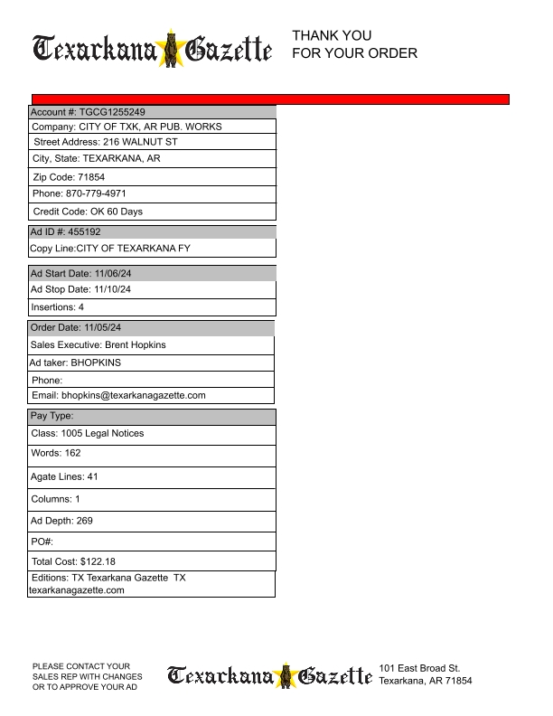
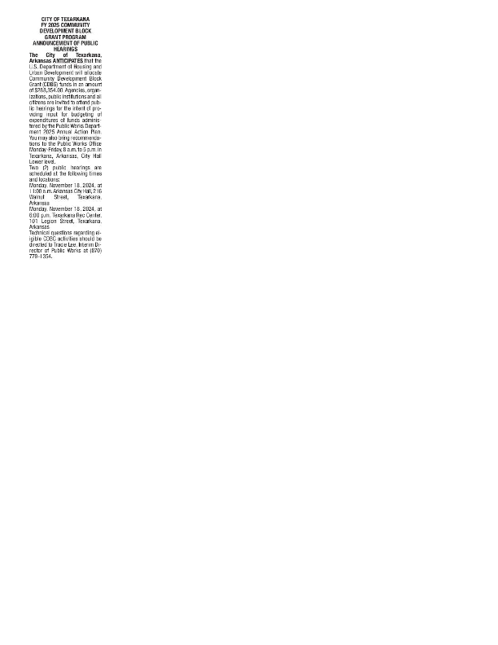

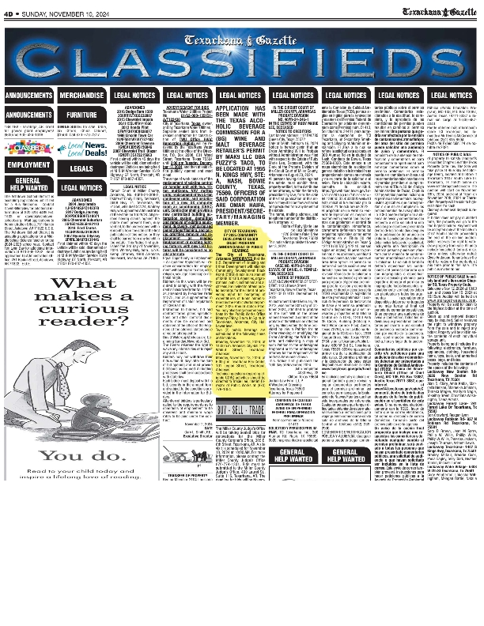
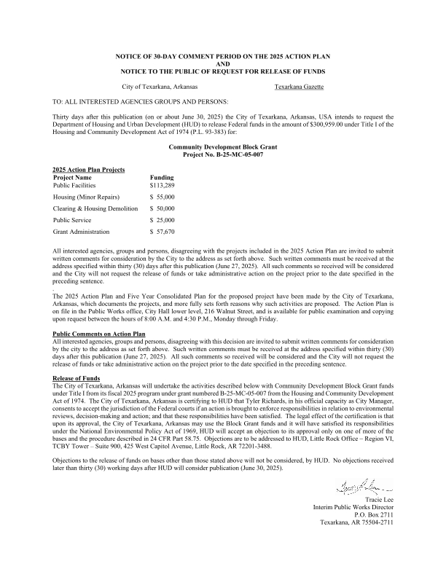
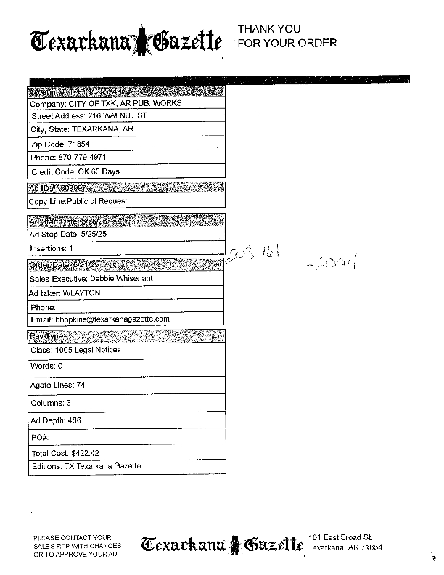
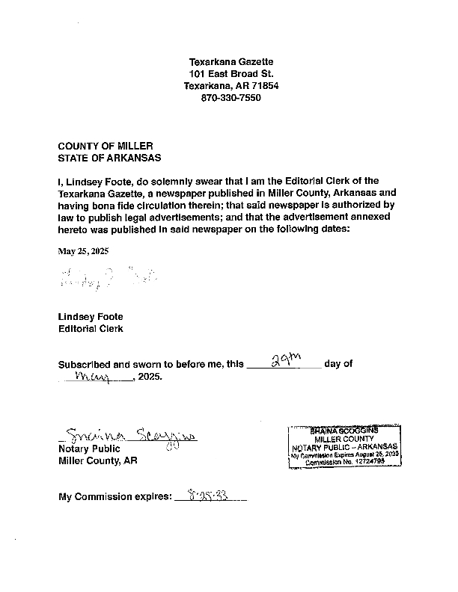

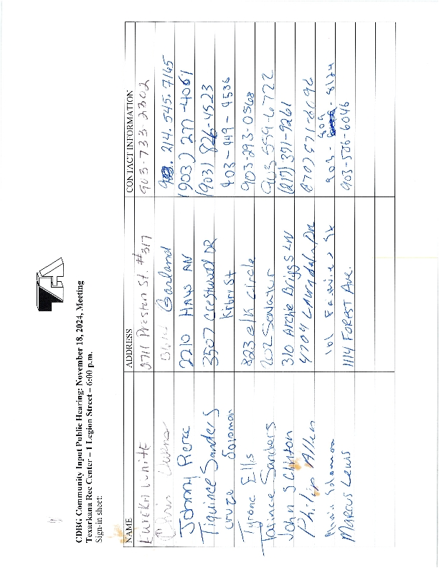
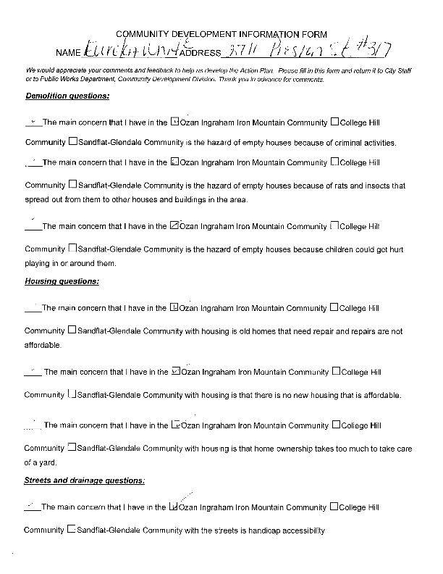
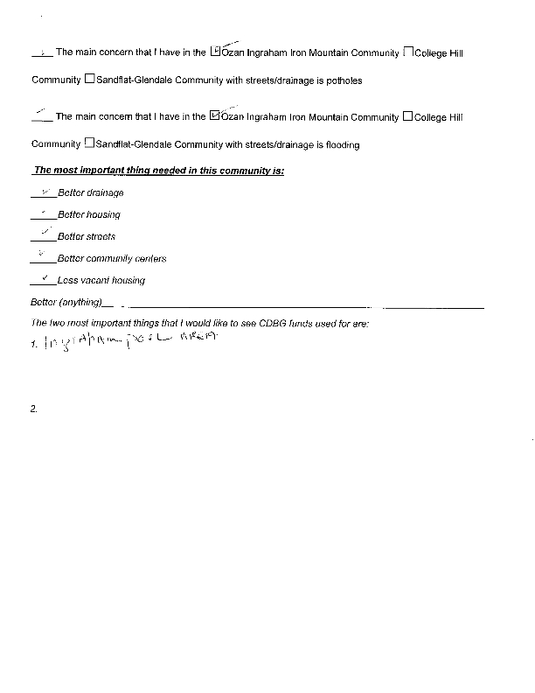
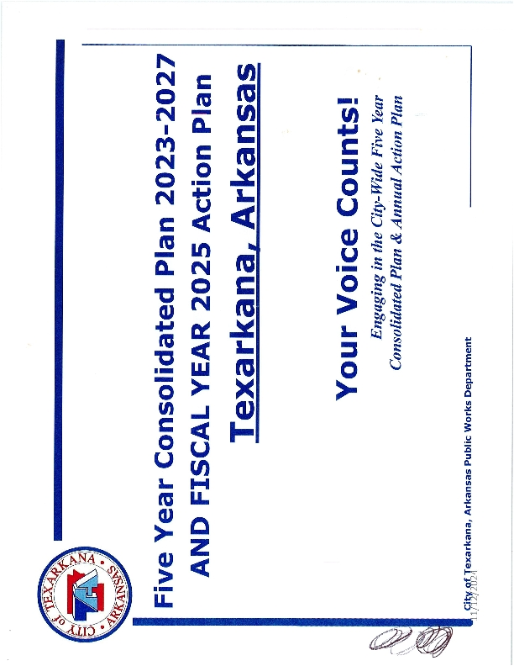
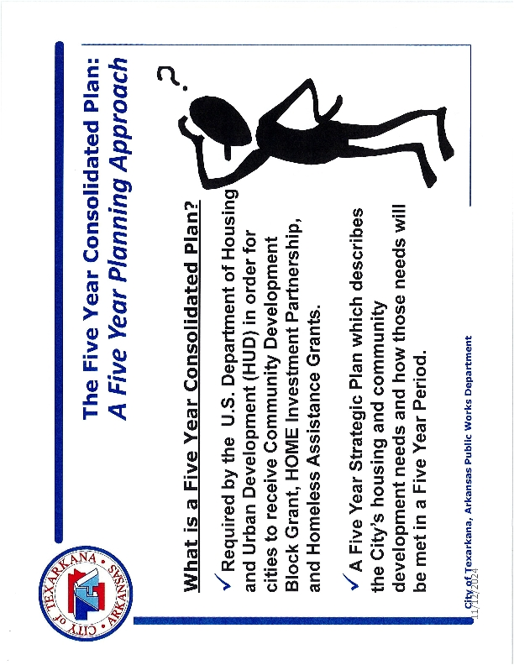
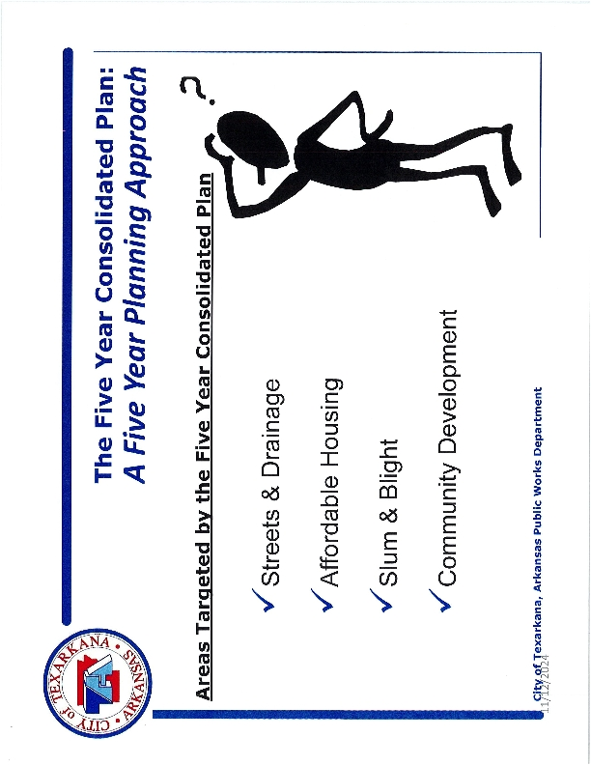
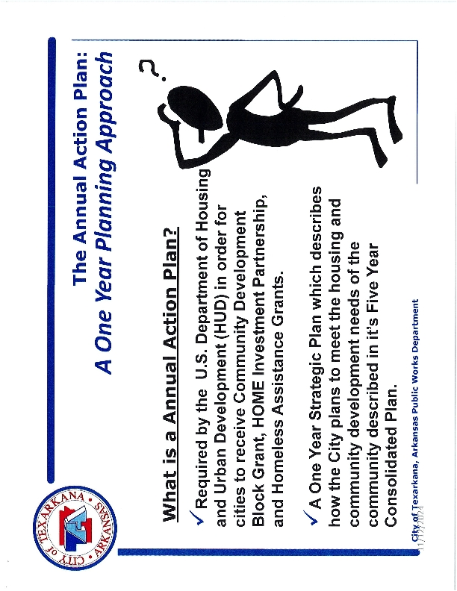
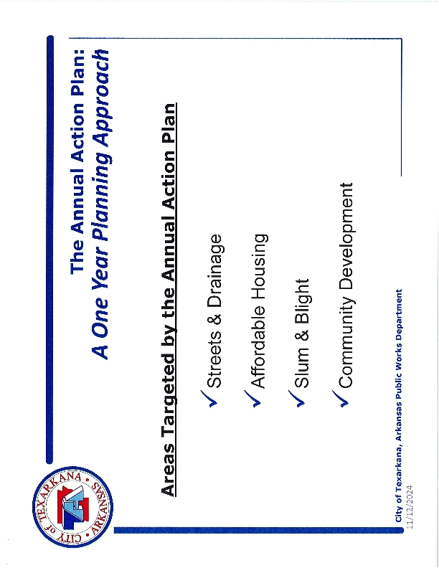
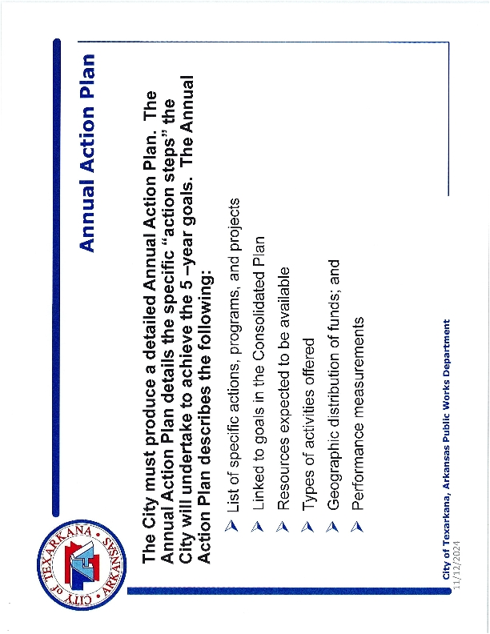
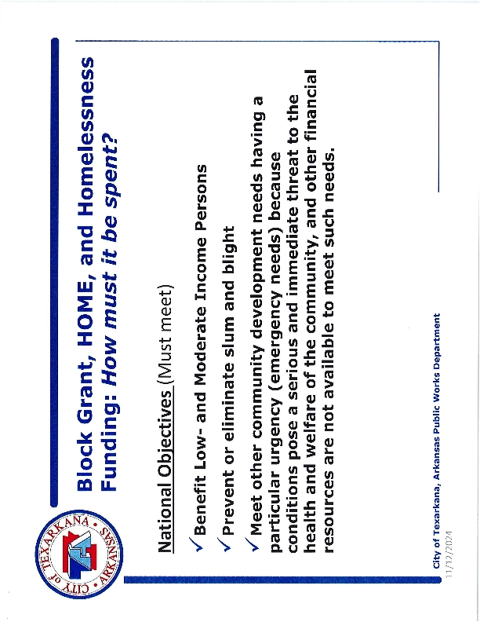
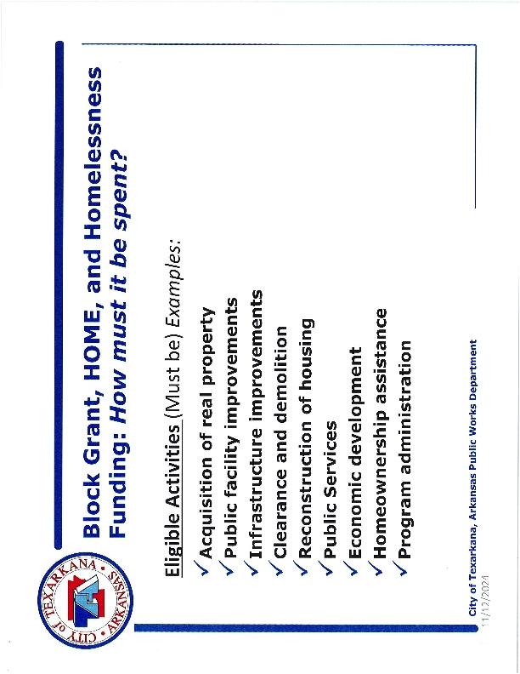
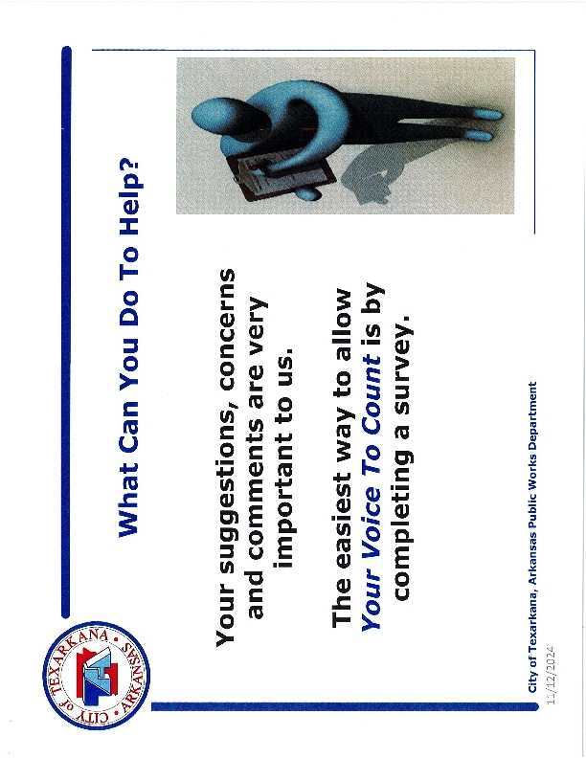
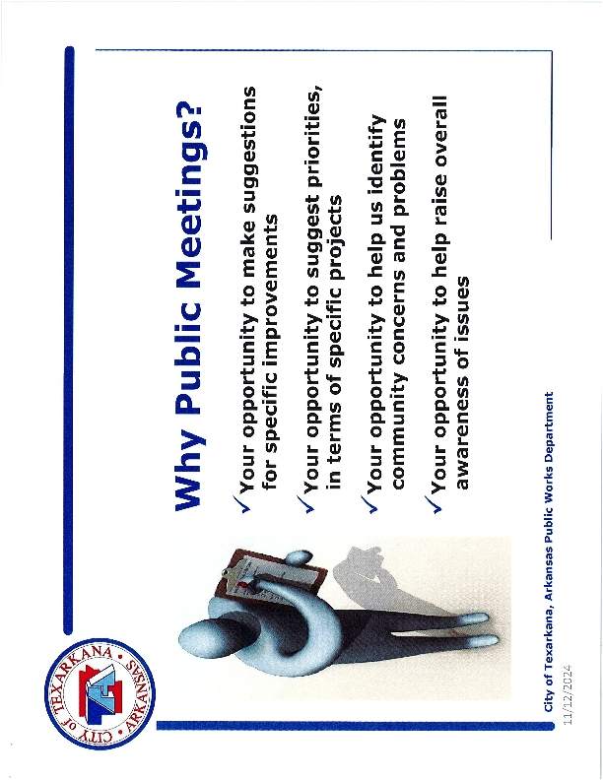
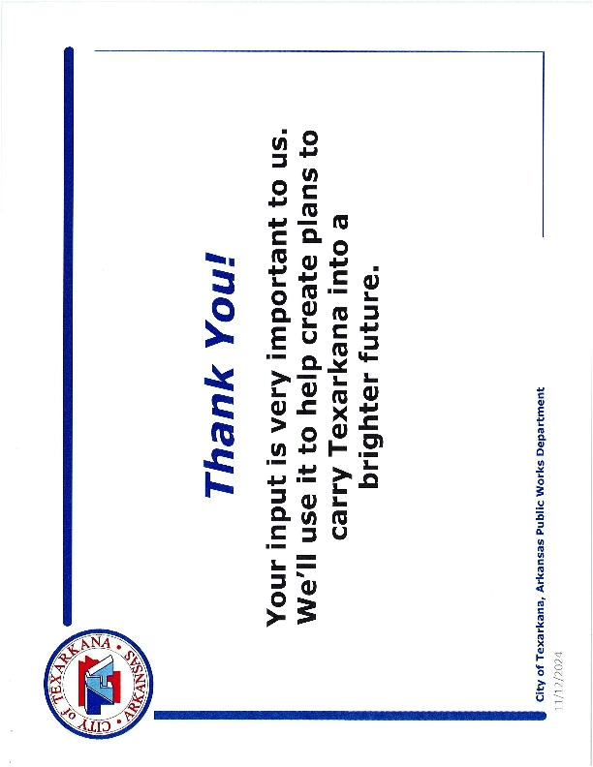
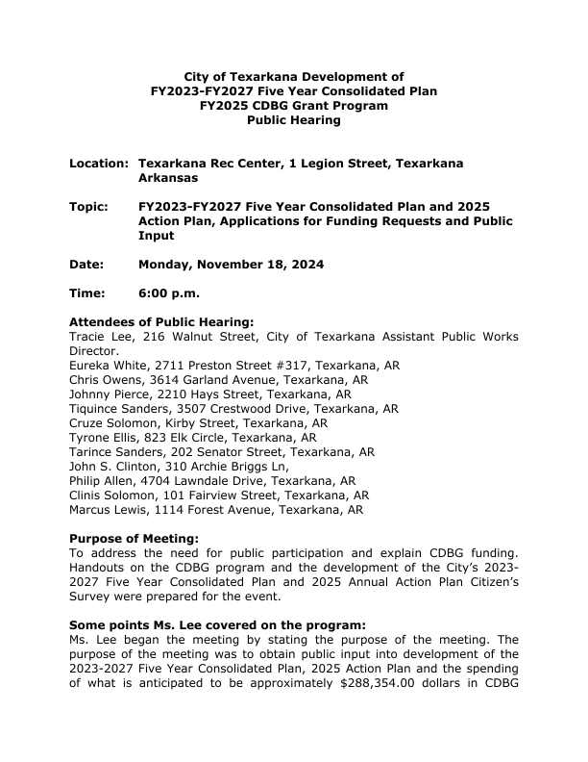
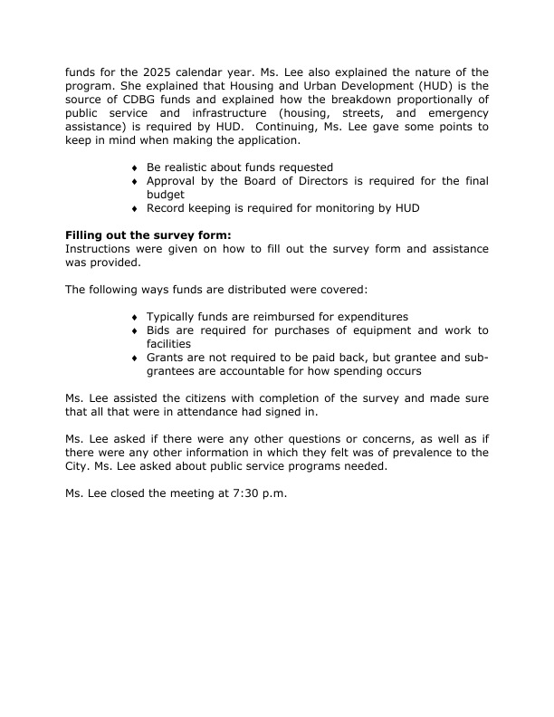

Grantee SF-424's and Certification(s)
